- The drop in UK CPI inflation in April was slightly smaller than we had anticipated. This was primarily due to larger once-a-year price hikes for many index-linked contracts and regulated prices. This development bakes in higher inflation for another year in these categories, so we now expect CPI inflation to average 2.5% in 2024, up from 2.3% last month.
- But we still think inflation will drop back to the Bank of England's 2% target in May. Base effects will continue to weigh. The indirect effects of lower energy prices should increasingly drag on food and core inflation. We also expect Ofgem to cut the energy price cap by 6% in July.
Despite falling to 2.3% from 3.2% the previous month, CPI inflation surprised to the upside slightly in April. Half of the drop in the annual rate came from the energy category, as Ofgem's near-12% cut in the price cap came into effect. Meanwhile, food price inflation cooled further. We had previously flagged there was a high degree of uncertainty surrounding April's core inflation outturn given once-a-year price hikes would kick in for index-linked contracts and regulated prices. The magnitude of these increases was larger than we had expected, to the extent that the m/m rise in services prices was only marginally smaller than last year's bumper increase. Elsewhere, RPI and RPIX both dropped by 1ppt to 2.3% and 3.3% respectively.
That some of April's upside surprise reflected larger increases for goods and services where prices change once-a-year means higher inflation is now baked in for another year in these categories. Therefore, we have raised our near-term forecast and now expect CPI inflation to average 2.5% in 2024, 0.2ppts higher than in last month's forecast.
Nevertheless, we should still see headline inflation returning to the Bank of England's 2% target in May then staying close to that rate for the rest of the year. Base effects will continue to exert downward pressure on y/y inflation rates in the near-term. Ofgem is due to announce July's energy price cap on Friday, and movements in wholesale gas prices suggest the cap will be cut by around 6%. Food inflation is likely to ease further as producer input costs in the sector continue to fall. Meanwhile, we think the indirect effects of lower energy prices will start to drag on core goods and services inflation more significantly soon.
Chart 1: Higher annual price hikes in core categories have raised our 2024 inflation forecast to 2.5%
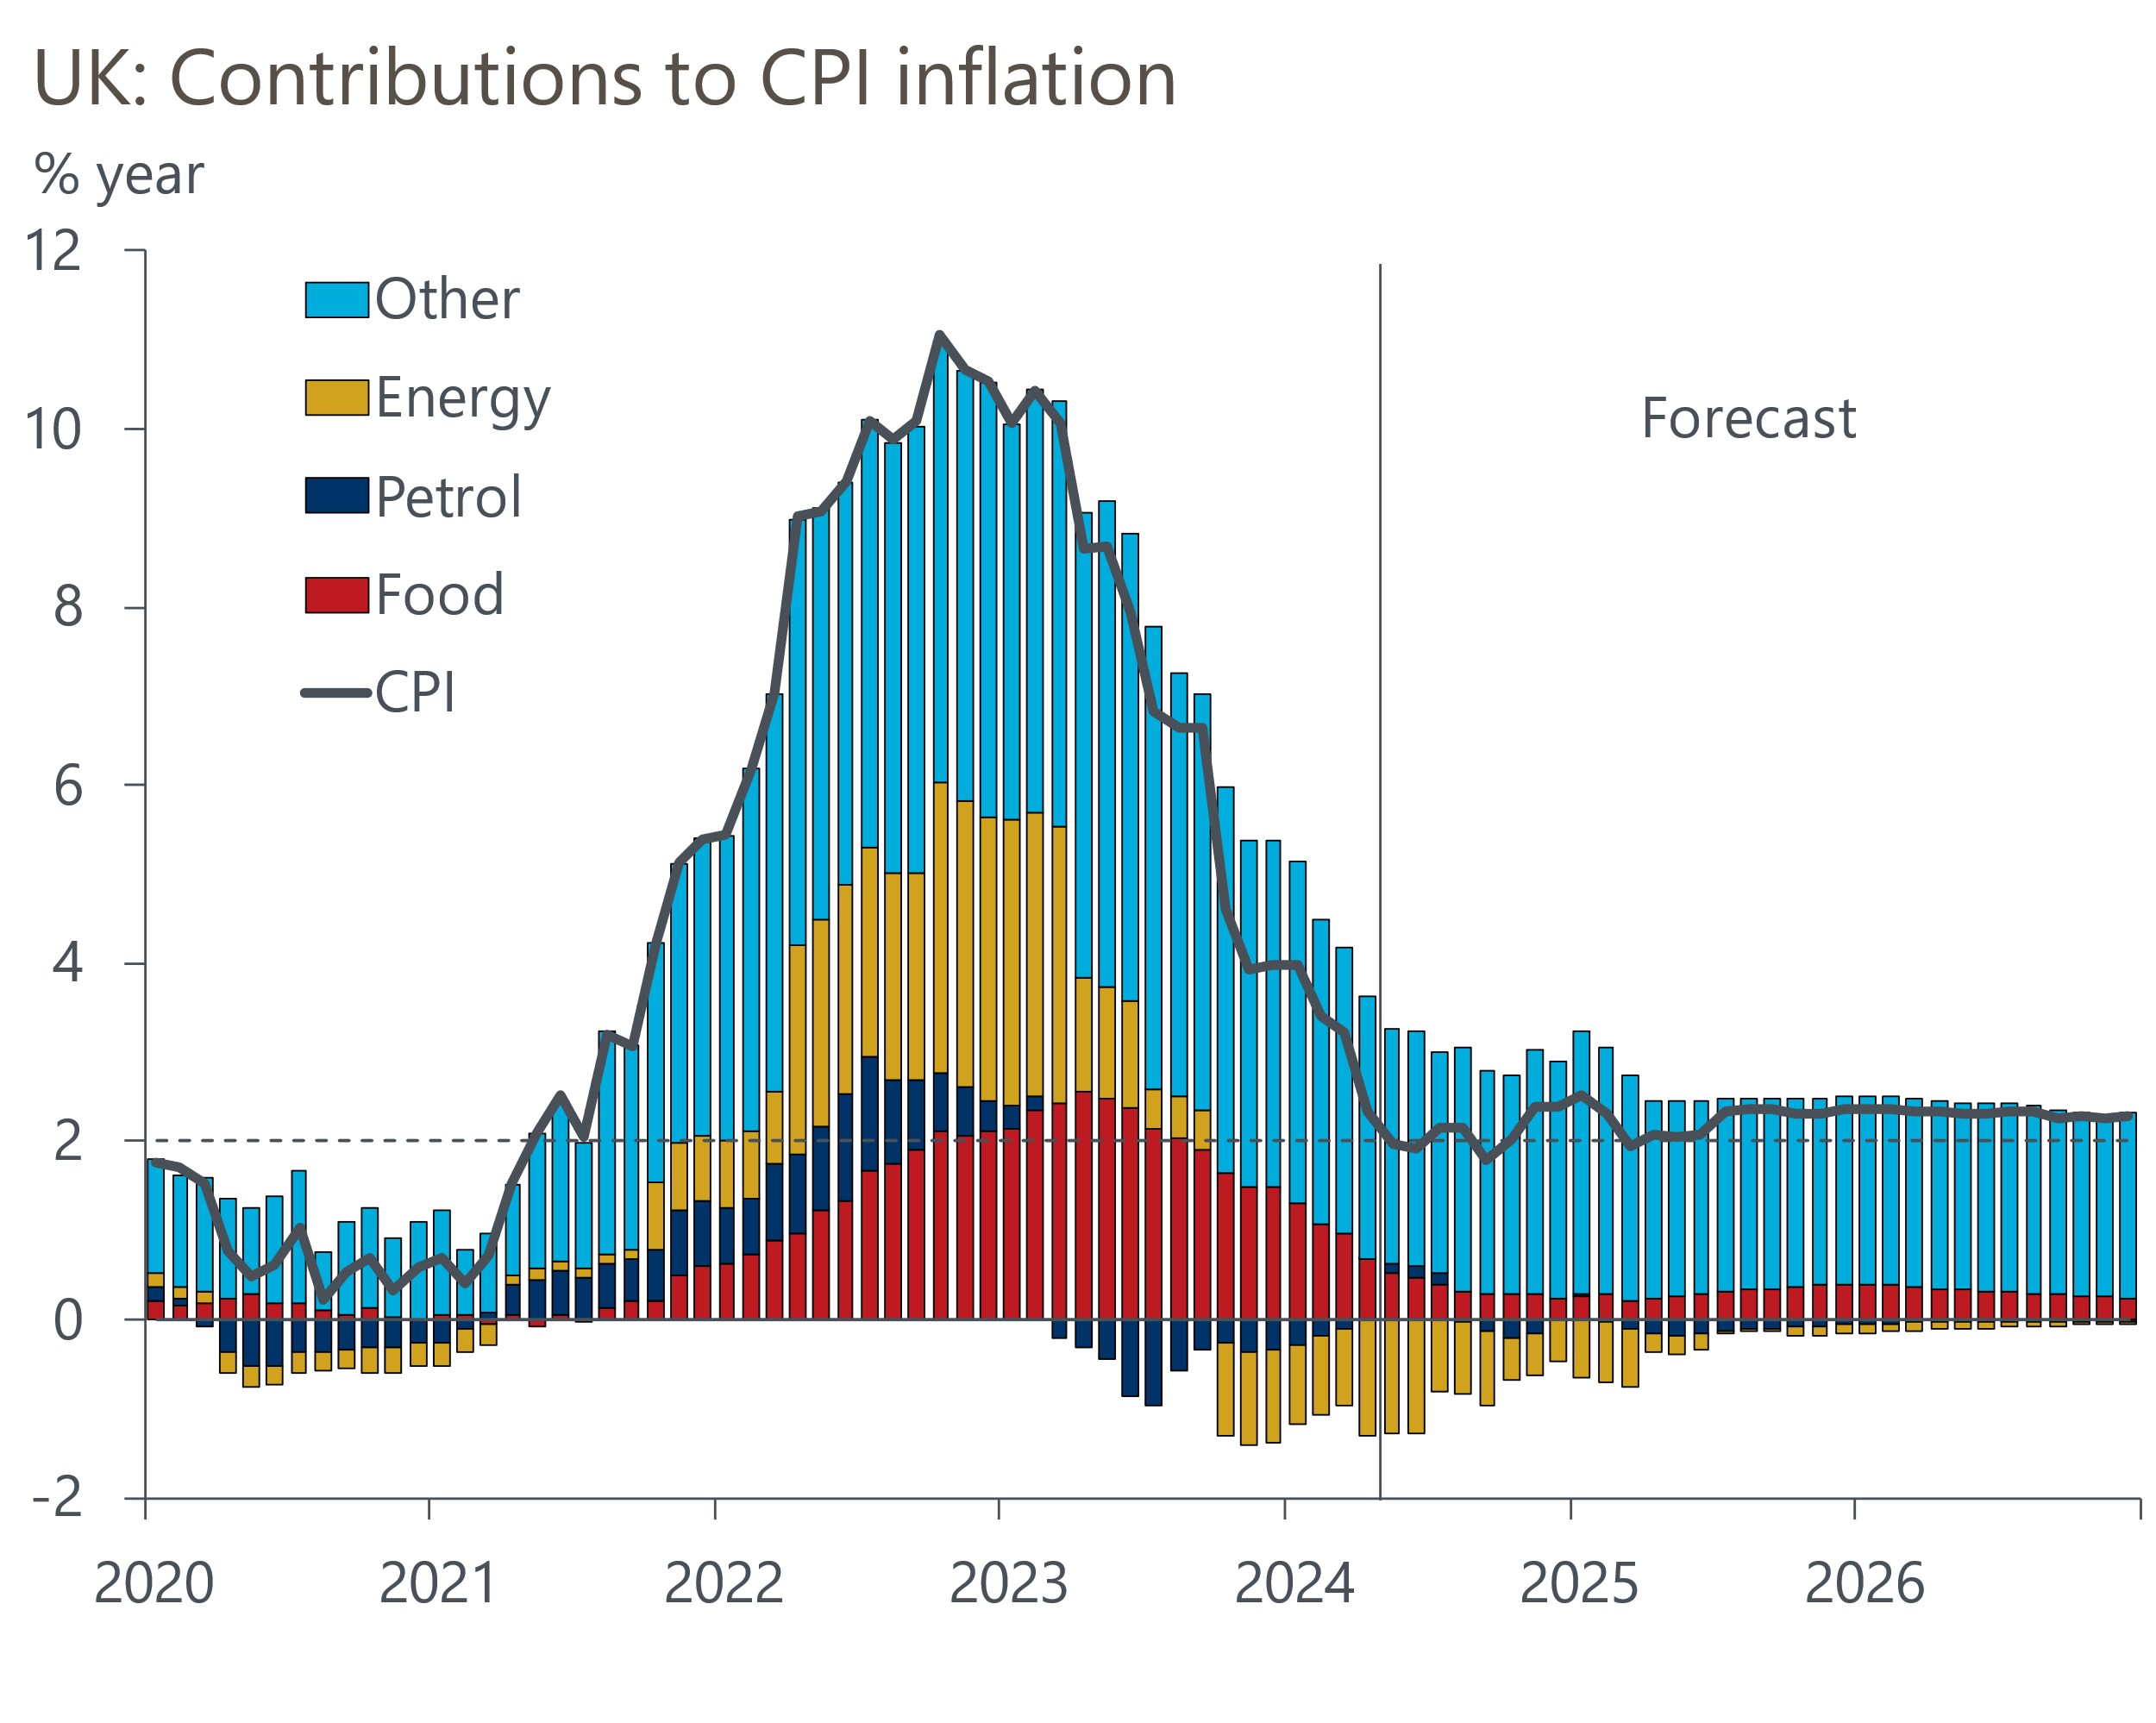
Source: Oxford Economics, Haver Analytics

